Pune City Guide

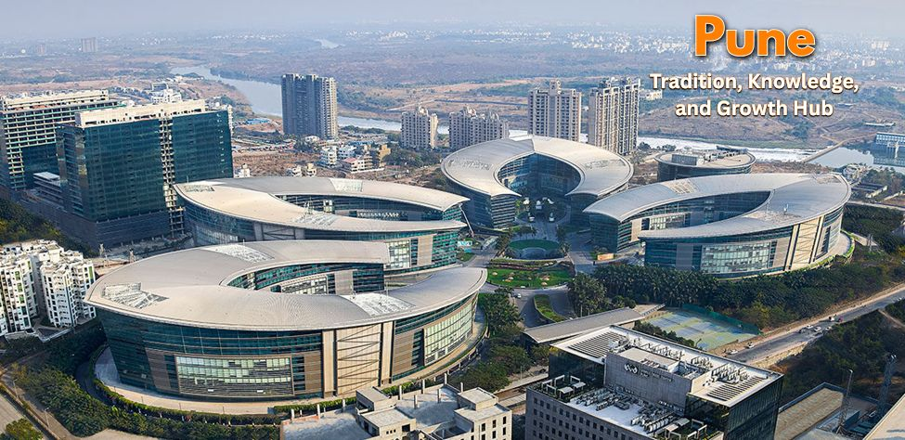
INDEX

- General Overview
- Housing
- Financial Services
- Healthcare
- Schooling
- Utilities
- Medial and Mail
- Telecommunications
- Transport
- Shipment of household Goods
- Expatriate Life
- Shopping
- Domestic Help

General Overview
Location & Geography:
Pune is a major city in the state of Maharashtra, India, situated on the Deccan Plateau near the western margin of the Sahyadri Hills. It is located at the confluence of the Mula and Mutha rivers, at an altitude of 560 meters (1,837 feet). Pune is known for its pleasant climate, rich history, and as a hub for education, business, and IT.
Area: Approximately 516.18 Square Kilometres
Background:
Pune, historically significant as a Maratha Empire hub and later under Peshwa rule, is now a major metropolitan city known for its rich cultural heritage, educational institutions, and burgeoning industrial sector. It's often called the "Oxford of the East" and the "Cultural Capital of Maharashtra".
Climate:
Pune experiences a tropical wet and dry climate with distinct seasons.
Summer: March–May, up to 40°C
Monsoon: June–September, moderate to heavy rainfall
Winter: November–February, as low as 8°C
Best Months to Visit: October to February

Pune receives southwest monsoon rains and has dry winters.
Time Zone:
Indian Standard Time (IST) – UTC +5:30
Population & Culture:
Population: Approx. 7.4 million (8th most populated city in India)

Languages Spoken: Marathi (official), English, Hindi.

Literacy Rate: 86.15%

National Holidays:

Republic Day – 26th January

Independence Day – 15th August

Gandhi Jayanti – 2nd October

Popular Festival Holidays:

Diwali
Dussehra
Gudhi Padwa
Makar Sankranti
Holi
Shivaji Jayanti
Christmas
Nag Panchami
Maha Shivratri
*Id-ul-Fitr
Maharvir Jayanti
Good Friday
Buddha Purnima
*Id-ul-Zuha (Bakrid)
*Muharram
Ganesh Chaturthi
*Id-e-Milad

Emergency Contacts
Police: 100
Fire: 104
Ambulance: 108
General Info (Justdial): +91 88888 88888

Housing Overview
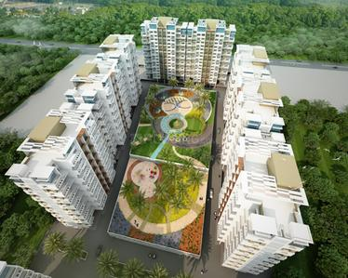

Neighbourhoods / Areas:

Pune’s rental market has recently seen steady growth—driven by metro expansion and rising IT demand—with rental rates increasing up to ~30% since 2021 in key areas, especially those near upcoming metro lines.

The city remains a landlord‑favoured market, where preferred expat/local professional areas command premium rates and limited availability. Transportation and traffic vary greatly—it's advisable for expats to use a car, driver, or chauffeur-driven service.

Preferred residential areas include Koregaon Park, Kalyani Nagar, Viman Nagar, Baner, Kharadi, Hinjawadi, Aundh, Wakad, and Kothrud—these localities offer strong infrastructure, green spaces, cafés, schools, hospitals, and solid connectivity to workplaces and the airport. Some of the newer expat clusters are emerging in Wakad and Baner due to metro developments and IT corridors

Housing Options:

Temporary Accommodation:
Temporary Accommodation:
A number of premium serviced-apartment blocks and hotels exist in central Pune and areas like Koregaon Park and Kalyani Nagar. It’s recommended to book well in advance during peak seasons (festivals or summer move-ins), as demand exceeds availability.

Long Term Accommodation:
Most flats and villas in these areas are within gated communities offering safety, maintenance, back‑up power, and amenities like pools, gyms, and clubhouses.

Independent houses/villas offer more space and privacy but typically require private security arrangements and self-maintenance.

Integrated villa communities combine the benefits of gated living with independent house privacy.
Community Profile:
Breakdown of available properties:
- Apartments: ~80%, mostly unfurnished (up to ~85–90%)
- Houses/Villas: ~20%, with more furnished

Houses:
Availability: Moderate to Good (varies by area – more availability in Baner, Aundh, Kharadi, and outskirts)
Detached: ~25%
Semi-detached: ~75%
Style: Modern and traditional bungalows with 3–4 bedrooms, attached bathrooms, separate kitchen, and living + dining areas. Many come with a small garden or backyard.
Average Age: 10–20 years
New Construction (<5 years): ~15% in newer townships like Hinjawadi Phase 2, Wagholi, Mahalunge, and Baner
Apartments:
Availability: Good
Located in:
• Small Buildings – 60–65%
• Large Apartment Complexes / High-rises – 35–40%
Styles: Typically, 2–3 bedroom configurations with attached bathrooms, a fair-sized master bedroom, modular kitchens, and combined living + dining spaces. Many offer balconies with city or garden views.
Average Age: 5-10 years
New construction: (5 years or less) 20%
The unique quality of housing in Pune is that you will find residential options across all budget categories—from economical flats to premium serviced apartments and high-end penthouses—within almost every major neighbourhood.

Most of the above-mentioned areas are dotted with parks, jogging tracks, gardens, and recreational spaces that are ideal for families, morning walks, and children’s play areas.

It is advisable to visit shortlisted neighbourhoods at different times of the day to get a true sense of:

- Traffic flow and congestion

- Noise levels

- Parking availability

- Proximity and actual travel time to work, schools, hospitals, and grocery stores

Serviced Apartments:
There are several serviced apartment options available across Pune, particularly in expat-friendly areas like Koregaon Park, Kalyani Nagar, Viman Nagar, Baner, and Hinjawadi. These cater to short-term stays for business travellers, relocating families, and expatriates.

The serviced apartments in Pune can be broadly classified into the following categories:

- Professionally Run Serviced Apartments

These are fully-managed buildings or blocks operated by professional companies.

- Found in premium locations (e.g., Koregaon Park, Kharadi, Baner)
- Offer dedicated housekeeping, reception, security, and maintenance teams
- Often include amenities like Wi-Fi, laundry, kitchenettes, parking, and 24/7 power backup
- Suitable for expatriates, corporate travellers, and families in transition
- Stand-Alone Serviced Apartments

This format is growing in popularity in Pune, especially around IT hubs.

- Usually individually owned or managed by small operators
- Quality and consistency may vary significantly
- Limited support staff; amenities like Wi-Fi or kitchenware may not be standard
- Not part of an organized sector—careful vetting is recommended before booking

- Guest Houses / Shared Accommodations

These are often homes converted into lodging spaces with shared kitchens and living areas.

- Rooms are rented individually, and common facilities are shared
- Typically used by interns, short-term visitors, or budget travellers
- Not recommended for expatriates or families due to privacy, security, and hygiene concerns
Rental Deposit:

In Pune, it is a standard procedure to give 2 to 5 months’ rent as a security deposit, depending on the locality and landlord preference. The security deposit is interest-free and refundable at the end of the lease term.

Things to Consider Before Signing a Lease
Location plays a vital role in choosing the right place to live. Consider carefully some of the following:
Convenience
- Proximity to schools, workplace, and markets
- Entertainment and recreation
- Transportation and traffic conditions
- Medical facilities

Environment
- Old and developed / new and developing
- Apartment / independent house / villas
- Safety
- Neighbourhood
- Community
- Leisure facilities

Budget
Check well if the rental quoted is inclusive of apartment associated maintenance costs. If the Landlord is providing you with utility connections, the set-up cost is borne by the Landlord, and the monthly rental and usage charges are borne by the Tenant. The monthly payment will have to be made directly to the vendors.
Please note that there is always a due date for making payments.

When considering a property, keep in mind the following:
• General appearance of the property and its location
• Layout of the property
• Construction quality
• Age of the property
• Condition of all electrical appliances supplied including air conditioners, washing machines etc.
• Check humidity / mildew damage
• Is the telephone, internet line and gas connection provided by the Landlord?
• Facilities available within the complex (in case of gated communities)
• The security arrangement
Keep in mind:

- Negotiate with the Landlord for a notice period / diplomatic clause in the lease
- Check for maintenance charges and move in, move out charges
- Gardener’s fee
- Club House membership – deposit and monthly usage charges
- Power back up facility
- Mosquito mesh on all doors, windows and ventilators
- Grouting of tiles, if required
- Geyser in kitchen
- Aqua guard (water purifier) in kitchen
- Painting of interiors and exteriors
- Pest control of interiors and exteriors if you plan to take a house or villa
- Check if the property has 24hrs security and maintenance services
- Check all plumbing and electrical fittings
Market practice and lease terms:

- Typical lease period: 11 months
- Deposit: 2 to 5 months’ rent
- Rent in advance: Monthly
- Brokerage: One month’s rent
- Lock-in and Diplomatic Clauses: Negotiable
- Lease registration: Mandatory in Maharashtra for agreements over 11 months (includes biometric and online e-registration)

Furniture Leasing

The furniture available for lease is pre-owned and the period of lease can vary according to one’s requirements. There is no guarantee and variety of furniture; it may vary from time to time. You can reach out to Kraft Mobility for a detailed information.

Financial Services Overview
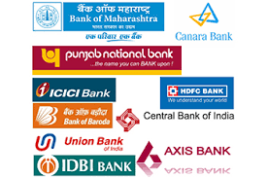
Currency:
The official unit of currency is the Indian Rupee. (Code: INR)
Coins are available in denominations of ₹1, ₹2, ₹5, and ₹10.
Banknotes come in denominations of ₹10, ₹20, ₹50, ₹100, ₹500, and ₹2000 (note: ₹2000 notes are gradually being phased out).

Currency Exchange:
Current exchange rates can be checked in daily newspapers, at banks, currency exchange counters, or online.
Foreign currencies can be exchanged at hotels, international airports, and RBI-authorized money changers throughout Pune.
Credit Cards:
Credit cards are widely accepted in Pune, particularly in malls, restaurants, hotels, and retail stores. Most banks issue credit cards with revolving credit and cash advance features. The most commonly accepted cards are RuPay, VISA, and MasterCard. American Express and Diners Club cards are accepted only at selected establishments. It is recommended to check with the merchant in advance before using a foreign-issued card.
Note: International cards may attract foreign transaction fees. Check with your home bank for exact charges.
ATMs:
Pune has a well-connected ATM network that covers all major residential and commercial areas.
- Most transactions are cash-based, although card payments are on the rise.
- 24-hour ATM and phone banking services are offered by most banks.
- No fee is charged for using your own bank’s ATM.
- For other banks’ ATMs, up to 5 free transactions per month are allowed (after which a small service fee applies).
- Daily cash withdrawal limits vary by bank and card type (generally between ₹20,000–₹1,00,000).
Traveller’s Cheques:
Traveller’s cheques are available through most major banks, both Indian and foreign. Currencies commonly available include the US Dollar, Euro, and Pound Sterling. To buy or encash traveller’s cheques, you must present a valid passport.

Opening a Bank Account (Pune):
Banks in Pune are divided into government (public sector) and private banks, including both local and international institutions.
Typical banking hours vary from 10:00–14:00 for government banks to 08:00–20:00 for private banks on weekdays. Some private banks also operate on Saturdays.
As a foreign national employed in India, you are permitted to open only one bank account per city, as per Indian Foreign Exchange and Income Tax laws.
Your relocation consultant or HR partner may assist you in opening one of the following:
Savings Account | Checking Account | Salary Account | Joint or Individual Accounts | Credit Card Account

Recommended Banks in Pune:
- HDFC Bank
- ICICI Bank
- HSBC Bank
- Standard Chartered Bank
- Citibank (only online operations)

Documents Required: (These may vary slightly by bank, but typically include):
- Duly filled account opening form
- Copy of Passport and Visa page
- Employer's letter confirming employment in India
- Lease agreement (as proof of local address)
- Passport-sized photographs
- Residential Permit (RP or RPRC) from FRRO
Most banks in Pune issue an ATM/debit card upon request, and the account opening process takes 2 to 15 working days depending on documentation and KYC verification.

Internet Banking Services:
All major banks in Pune offer internet and mobile banking services, allowing users to perform:
- Balance enquiries
- Fund transfers
- Bill payments
- International remittances
- Investment tracking
Internet banking is generally secure and user-friendly, with 24/7 support and app-based services provided by most leading banks.

Healthcare
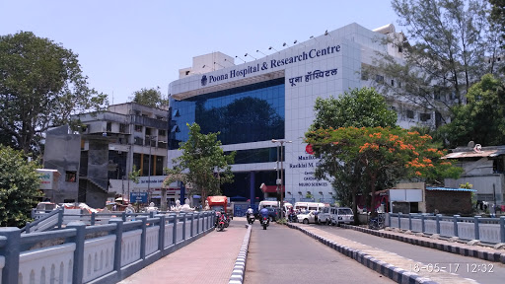
Prevention and Immunisation:

Health Risks:
Water-borne diseases such as hepatitis A, typhoid, dysentery, and diarrhea spike during monsoon due to contaminated water and poor sanitation. A notable surge in hepatitis A cases was observed between March–June 2025.
Vector-borne illnesses including dengue, malaria, chikungunya, and others like scrub typhus, are prevalent during and after the monsoon season.
Respiratory illnesses frequently escalate due to worsening air quality, including cases of asthma, COPD, and influenza-like illnesses (H1N1, H3N2) especially in winters. AQI data shows a decline in clean-air days, contributing to increased health risks.
Open burning of garbage in neighbourhoods continues to add to harmful air pollution and respiratory burden.
The following are some of the recommended vaccinations for India:
Ensure you are up to date with routine immunizations, such as MMR, DPT, polio, and influenza, especially before monsoon and winter seasons.
Hepatitis A vaccination is highly recommended for everyone over one year old (especially important in Pune during monsoon peaks).
Typhoid vaccine (oral or injectable) is advised for all travellers, urban and rural.
Hepatitis B, rabies, and meningococcal vaccines may be recommended depending on exposure risk (healthcare work or animal contact).
Cholera, Japanese encephalitis (JE) vaccination may be considered for high-risk travellers or long-duration stays.
Few Tips:
- Drink only boiled, filtered, or bottled water. Avoid street food and raw items like chutneys and salad during the monsoon.
- Use mosquito repellent, nets, and wear long-sleeves during monsoon to avoid vector-borne illness. Keep environments dry/fixed to prevent mosquito breeding.
- On poor air-quality days, sensitive individuals (children, elderly, asthma/COPD patients) should limit outdoor activity and use air purifiers or masks as needed.
- Maintain good indoor hygiene, avoid dampness/mold, ensure ventilation, and discourage open burning of waste around homes.

Medical Emergency Checklist:
In case of a medical emergency, knowing the closest hospital is critical. While Pune traffic is generally manageable, it can still delay emergency response—especially during peak hours or in areas under metro construction. It’s usually faster to take your own vehicle or hire an auto/cab rather than wait for an ambulance, unless the patient is immobile.
It is recommended to have someone accompany you to the hospital to assist with registration, payments, or form-filling. Most private hospitals require partial payments at the time of admission. Always carry personal identification (passport, visa copy, or resident permit) with you.
Expatriate-Preferred Hospitals in Pune
- Jehangir Hospital (Sassoon Road – Near Pune Station)
- Ruby Hall Clinic (Sassoon Road, Wanowrie & Hinjawadi branches)
- Columbia Asia Hospital (now Manipal Hospital) – (Kharadi, Hadapsar)
- Deenanath Mangeshkar Hospital (Erandwane – Central Pune)
- Sahyadri Hospital (Multiple branches – Deccan, Nagar Road, Bibwewadi, Kothrud)
- Aditya Birla Memorial Hospital (Chinchwad – PCMC Area)
- Noble Hospital (Hadapsar)
- Manipal Hospital (Baner – Near Aundh IT hub)
- Apollo Spectra Hospital (Sadashiv Peth – near Deccan)
- Cloudnine Hospital (Shivaji Nagar, Kalyani Nagar, Baner – Maternity & Pediatrics)
Prescription Medications:
Medical Facilities:
Doctors, clinics, and hospitals are easily accessible throughout Pune. The city is home to several reputed multi-specialty hospitals with advanced healthcare services at comparatively affordable costs. Communication with doctors is generally smooth, as most speak fluent English and Hindi. Private hospitals are recommended for faster and more personalized care. Pune has a large network of general physicians, specialists, and wellness clinics. When choosing a doctor, consider their affiliated hospital for ease of admission in emergencies.
Pharmacies:
Medications are easily available over the counter at most pharmacies. Pharmacies are spread across every neighborhood and many offer home delivery. It’s advisable to carry prescriptions, especially for ongoing treatments, and inform your doctor about any medication you are currently taking.

Some 24-Hour Pharmacies in Pune:
- Jehangir Hospital Pharmacy
- Apollo Pharmacy, Aundh
- Apollo Pharmacy, Viman Nagar
- Medicare Forever Chemists & Lifestyle Store
- Deenanath Mangeshkar Hospital Pharmacy
Emergency / Ambulance Service:
Emergency Ambulance (Government): 102
Private Ambulance Services (24x7):
- Ruby Hall Ambulance: +91 20 6645 5555
- Jehangir Hospital Ambulance: +91 20 6681 9999
- Sancheti Hospital: +91 20 2553 4535
Security Tips:
- Avoid Over-Reliance on Strangers:
Taxi drivers, auto rickshaw drivers, or self-proclaimed tourist guides may not always be trustworthy. Maintain a safe distance and avoid sharing personal information.
- Choose Safe Residential Areas:
It is recommended to stay in gated communities or apartments with 24/7 security. If staying in an independent home, consider hiring a security guard from a trusted agency.
- Be Aware of Petty Crimes:
While Pune is relatively safe, incidents like mobile snatching, bag theft, or pickpocketing do occur. Stay alert in crowded places and public transport.
- Avoid Isolated Areas:
Do not go alone to deserted or poorly-lit areas, especially at night. If heading out after dark, always stay with a group or inform someone about your whereabouts.
- Limit Cash and Valuables:
Carry minimal cash. Keep valuables, documents, and excess money securely locked at your residence.
- Mind Your Wallet:
Avoid keeping your wallet in your back pocket. Use side pockets or inside compartments of bags or jackets for safety.
- Respect Local Culture:
While visiting religious sites like temples or gurudwaras, dress conservatively and behave respectfully.
- Keep Document Copies:
Carry photocopies (or scanned versions on your phone/email) of important documents such as passport, visa, residential ID, etc.
- Research Before You Go Out:
Learn about places you plan to visit beforehand. It helps you avoid scams or misinformation.
- Watch Out on Roads:
Pedestrians don’t always get the right of way. Be extra careful while crossing streets or walking near traffic.

Police:
Police emergency number: 112
Schooling Overview
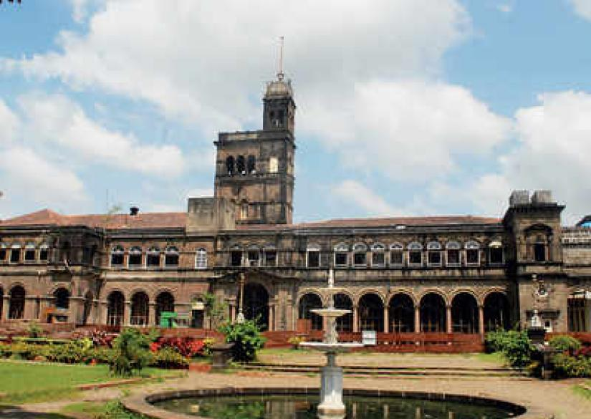
Pune Schools:
Education in Pune spans from Kindergarten through Higher Secondary. Schools are affiliated with several education boards:
Maharashtra State Board of Secondary & Higher Secondary Education (MSBSHSE) oversees SSC (Class 10) and HSC (Class 12) exams. This state board is headquartered in Pune and serves over 10,000 schools.
National and International Boards present in Pune include CBSE, CISCE (ICSE/ISC), NIOS, IB, and Cambridge (IGCSE)
Schools are categorized as:
- Government (run by the state)
- Aided (private schools with government funding)
- Unaided private (independent schools with no government funding)
After Class 10, students typically join Junior College (PUC) or schools offering +2 courses under the state or national boards, followed by higher education programs in colleges, universities, and vocational institutions.
International Schools:
Expat and globally minded families have several excellent options:
- Indus International School, Pune (Kharadi/Balewadi) – CBSE & IGCSE curriculum; strong leadership and entrepreneurship programs
- Victorious Kidss Educares (VKE) – IB World School in Kharadi offering PYP, MYP, and IBDP
- Symbiosis International School (Viman Nagar) – Offers IB PYP, MYP, Cambridge IGCSE, and IB Diploma
- Mahindra International School – First IB-authorized school in India; private co-ed institution in Pune
- Elpro International School – Offers CBSE, IB, and Cambridge curricula; top-rated in Pune
- The Lexicon International School – CBSE-based international school with multiple campuses in Pune
- Kothari International School (Kharadi) – CBSE day boarding with modern facilities and labs
- Global Indian International School (GIIS) – CBSE smart campus opening in 2026 in Charholi area, with two current campuses in Hadapsar and Balewadi
The following are suggestions to assist you in making the best decision:
- Ask local expatriate families for referrals and preferred schools.
- Schedule visits to shortlisted schools: observe class interaction, student-teacher engagement, and overall campus vibe.
- Inquire about teacher-student ratios, teacher credentials, and curriculum alignment.
- Examine safety standards, sanitary conditions, and adequacy of educational & play equipment.
- Demand a full breakdown of fees, transportation policies, refund rules, and admission terms.
- Notify schools of any learning needs or disabilities during admission for better support.
Language & Policy:
Under Maharashtra’s implementation of NEP 2020, all schools now follow a 3-language policy: Marathi (mandatory), English, and another Indian language of choice
The State Curriculum Framework (SCF) mandates community integration in learning—students’ involvement in local heritage, crafts, and environment is now part of assessments via School Management Committees

Utilities Overview
Electricity Supply & Charges:
Electricity in Pune is primarily supplied by Maharashtra State Electricity Distribution Company Limited (MSEDCL / Mahavitaran) and in some areas by Tata Power or Adani Electricity.
- Charges are based on consumption slabs, and tariffs increase with higher usage.
- The bill due date is clearly printed on each monthly electricity bill.
- Late or missed payments can result in disconnection of the power supply without additional notice.
- Bills can be paid through:
- Online portals (e.g., www.mahadiscom.in)
- Mobile apps like MahaDiscom app or Paytm
- Electricity department offices near your locality.
- Authorized bill payment centers at local stores or banks.
Tip: Consult your relocation coordinator or landlord to identify your area's electricity provider and the nearest payment office.
Voltage:
- Standard voltage: 240 Volts
- Frequency: 50 Hertz (Hz)
- Plug types: Type C, D, and M (you may need adapters if coming from the US, UK, or other regions)
Resistor-Network Converters:
- Wattage: 50 – 1600W
- Best for high-wattage appliances like hair dryers, irons
- Not suitable for long-term or sensitive electronics
Transformers:
- Wattage: 50 – 100W
- Ideal for continuous use with laptops, chargers, cameras, audio devices
- Heavier but provides stable voltage
Combination Converters:
- Offers both modes (resistor + transformer)
- Switch between modes depending on the appliance
- Best for travelers or long-term foreign residents with various gadgets
Water:
If you are living in an independent house or bungalow in Pune, you will receive a monthly water bill from the Pune Municipal Corporation (PMC) or PCMC (depending on your location). The due date for payment will be mentioned on the bill.
You can pay your water bill:
- Online via the PMC/PCMC website
- At designated water bill counters
- Through mobile payment apps like PayTM, Google Pay, etc.
Tip: Contact your relocation coordinator or landlord to know which authority manages water supply in your area and for the address of the nearest office.
Garbage Disposal:
Garbage is collected door-to-door daily in most Pune localities by PMC-appointed staff. In gated communities or societies, the Society Maintenance Office may manage scheduled pickups on fixed days.
Waste is usually segregated into wet and dry garbage. Most societies expect residents to follow this system.
For any complaints or missed pickups, you can call the PMC Solid Waste Management Helpline:
1800 1030 222 (Toll-free)
Gas (Bottled LPG Cylinders):
In Pune, most households use bottled gas (LPG) provided by government-authorized agencies like:
- Bharat Gas
- HP Gas
- Indane Gas
Cost: Ranges between ₹900 to ₹1100 per cylinder (subsidized or market rate). You need a minimum of 2 cylinders for seamless usage.
To apply for a new connection, you’ll need:
- Identity proof
- Address proof
- Passport-sized photo
Delivery time after booking: Usually 1–4 days. Booking methods: Phone call, SMS, or mobile apps (specific to your gas provider)
Pest Control:
Since Pune has a warm climate, regular pest control is advisable for insects like ants, cockroaches, and mosquitoes.
Common services offered:
- General pest control
- Anti-termite treatment
- Rodent control
- Mosquito fogging (in select areas during monsoon)
Frequency: Once every 3–6 months. Ensure the service provider uses WHO-approved chemicals, especially if you have children or pets.

Media and Mail Overview

Television:
Cable and Satellite:
In Pune, once you move into your new residence, a local cable service provider from the area will typically reach out or can be easily contacted for a connection. A nominal installation charge is generally applicable, and the connection is usually set up within 1-2 days. Monthly subscription charges are to be paid in cash or via online modes, and you will receive a payment receipt. Most cable operators in Pune provide access to a wide range of popular channels such as STAR, Sony, Colors, ESPN, National Geographic, Discovery, and regional channels in Marathi and Hindi. For a full list of available channels, it is advisable to contact your local cable operator directly.

Alternatively, Direct-To-Home (DTH) satellite services like Tata Play (formerly Tata Sky), Airtel Digital TV, Dish TV, and D2H are widely available across Pune. These services require a one-time setup fee that includes the cost of the dish antenna, set-top box, and an annual or monthly subscription package. Installation typically takes between 2-5 working days, depending on technician availability. DTH providers offer a wide range of standard and HD channels in various languages, and you can customize your channel packs according to your preference. Contact your preferred service provider for the latest channel packages and pricing.
Radio:
Pune offers a wide range of FM radio stations that cater to diverse musical tastes and local interests. These channels are freely accessible and can be tuned in using any standard FM radio set or even via mobile phones with radio capabilities. Popular FM channels in Pune include Radio Mirchi (98.3 FM), Red FM (93.5), Radio City (91.1 FM), Big FM (92.7), and All India Radio (AIR FM Rainbow – 107.1 FM). These stations provide a mix of Bollywood hits, indie music, talk shows, traffic updates, and local news, offering entertainment and information around the clock. Whether you're commuting or relaxing at home, Pune's FM radio channels ensure there's always something engaging to listen to without any subscription or cost.
Newspaper:
Pune offers a variety of daily newspapers in English, Marathi, and Hindi. Popular English dailies include The Times of India, Indian Express, and Hindustan Times, while Marathi readers often choose Sakal or Lokmat.
You can:
- Buy them from local newspaper stalls.
- Subscribe through local distributors.
- Opt for online subscriptions or e-papers.
Post Office:
Pune has a well-connected network of post offices located across residential and commercial areas, offering a wide range of communication and mailing services to residents and businesses alike.
Postal services available include:
- General postage for letters and parcels
- Speed Post
- Registered Post
- Logistics and Business Post
- Direct Post (for advertising mailers)
- Money Orders
- International Money Transfers
For detailed information on services, rates, and timings, you can visit your nearest local post office.

Telecommunications Overview

Telecommunications in Pune:
Telephone and broadband connections in Pune are available through both government provider BSNL and private operators like Jio, Airtel, and Vodafone. Private providers usually complete installation within 2–5 days, while BSNL may take up to 14 days. Required documents include ID proof, address proof, passport copy, and photographs. A refundable deposit and installation fee are applicable. Monthly billing is standard, and timely payment is essential to avoid disconnection. Landlines with international calling can be activated on request. Service providers offer various prepaid/postpaid plans, and bills can be paid online or at customer centers. Some landlords may offer a pre-installed landline, where only usage charges apply.
Public Pay Phones:
Public phone booths with PCO/STD/ISD facilities are now extremely rare in Pune, with the widespread use of mobile phones largely replacing them.
Mobile Phones:
In Pune, major GSM service providers include Jio, Airtel, and Vodafone. They offer a range of post-paid and prepaid plans suited to different usage needs. Post-paid connections typically require a nominal deposit and activation fee, with an additional deposit for international roaming. Prepaid SIM cards are widely available at local mobile shops across the city. As per government regulations, new mobile connections require a valid photo ID and proof of address for activation.
Internet:
In Pune, internet services are offered by major providers such as Airtel, Jio, Tata Fiber, and BSNL. These companies provide broadband connectivity primarily through fiber-optic or wired telephone lines. After finalizing your residence, you will need to check area-specific coverage with your preferred provider. A variety of internet packages are available based on speed and data usage, catering to different household and business needs.

Transport Overview
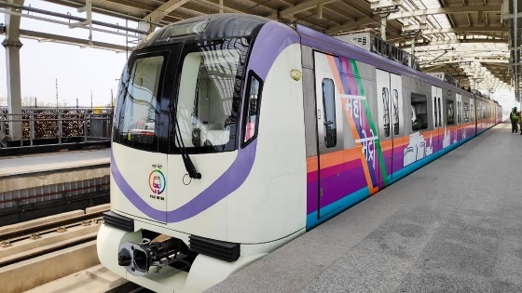 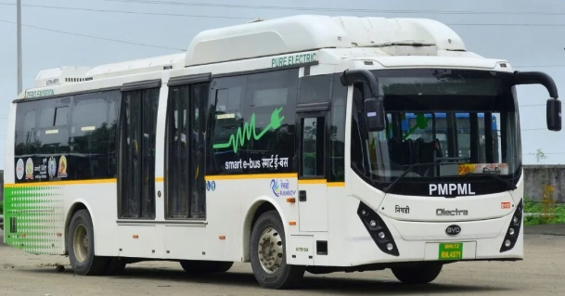
Public Transportation:
Pune, one of Maharashtra's major cities, offers a range of transportation options for both locals and expatriates. The city is moderately well connected through different modes of transport such as cabs, auto rickshaws, local buses, and metro rail (limited routes). For expatriates and business travelers, it is recommended to use app-based cab services like Ola, Uber, and InDrive for safety, convenience, and ease of communication. These services are accessible via mobile apps and provide various categories of vehicles based on comfort and budget.
Cabs / Cars:
There are several cab aggregators in Pune that offer reliable metered rides across the city. Ola, Uber, and InDrive are widely used and are preferred for their GPS tracking, digital payment options, and ease of booking. It is advised to avoid unlicensed taxi operators, especially late at night. Most drivers may not speak fluent English, so having your destination pinned on the map or written down is helpful.
Safety Tips:
- Always check your belongings before leaving the cab.
- Avoid travelling alone at night if you're unfamiliar with the area.
- Tipping is not mandatory, although some drivers may expect it from foreign nationals.
Auto Rickshaws:
Auto rickshaws are a common mode of transport in Pune. They are metered vehicles, but drivers often negotiate flat fares, especially during peak hours or after dark. By law, meters must be used, and passengers should insist on using them. After 10 PM, they may charge 1.5 times the fare. If the meter is faulty or refused, agree on the fare before starting the ride.
Buses:
Public buses in Pune are operated by the Pune Mahanagar Parivahan Mahamandal Limited (PMPML). These buses connect most areas of the city and are an economical option. While many are non-air-conditioned and crowded, AC buses (Rainbow BRTS) are more comfortable. However, for expatriates unfamiliar with routes and local languages, this may not be the most convenient option.
Metro:
The Pune Metro is under development, with a few routes operational, such as between Vanaz and Ruby Hall Clinic, and PCMC to Civil Court. Though currently limited, the metro aims to ease traffic congestion and will eventually become a reliable urban commuting option.
Airport:
Name: Pune International Airport
Website: https://www.aai.aero/en/airports/pune
Location: Located in Lohegaon, about 10 km from the city Centre.
Connectivity:
- Taxis and app-based cabs (Uber, Ola) are the most convenient way to get to/from the airport.
- Auto rickshaws operate up to the airport but may not be the most convenient option for foreign travelers.
- The airport is relatively small and can get congested during peak hours, so plan ahead.
Car Rentals:
Pune has several international and local car rental companies that provide both self-drive and chauffer-driven options.
Few of the companies include:
- Orix
- Hertz
- Kraft Mobility
- Zoomcar (app-based self-drive)
- Myles (app-based self-drive)
While self-driving is an option, Pune's traffic, narrow roads, and unpredictable driving culture make it challenging for newcomers. It’s advisable to opt for a chauffeur-driven car. If your employer has tied up with a rental agency, you can enjoy discounted corporate rates.
Driving and Licences:
Driving in Pune can be a daunting experience for expatriates due to irregular traffic, lack of lane discipline, and frequent congestion. Many roads are poorly maintained and signages can be confusing. If you’re unfamiliar with Indian driving practices, it is better to hire a driver or use chauffeur-driven rentals.
Driving Licence:
Foreign nationals can drive in India using an International Driving Permit (IDP) along with their valid national driving licence for a limited period. For long stays, it’s recommended to apply for an Indian driving licence.
Purchasing or Importing Vehicles:
Importing a vehicle into Pune is legally permitted but comes with strict regulations and heavy import duties (around 150%). It also involves a lengthy clearance and compliance process.
If you choose to buy a vehicle locally, keep in mind:
- Prioritize models with good mileage and low maintenance cost.
- Look for vehicles with high resale value and available service centers.
- Ensure the vehicle has features like air conditioning, ABS, airbags, and power steering.
- Used cars are available at lower prices, but make sure ownership documents are thoroughly verified and transactions go through trusted dealers.

HHG Shipment Overview
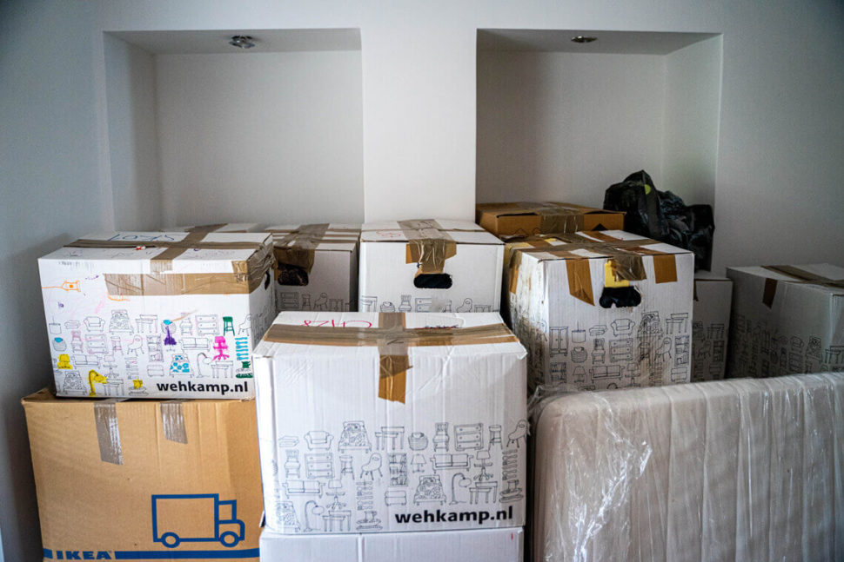
Household Goods Shipment:
Indian nationals and foreign nationals, including those of Indian origin, who are transferring their residence to Pune or arriving in the city for employment, are allowed to import their personal effects and household goods into India free of duty, subject to specific conditions. If the owner of the goods is an Indian national, they must have resided overseas for at least two years and must be returning to India to settle. Additionally, they should not have stayed in India for more than 180 days during the preceding two years. For foreign nationals relocating to Pune, a valid Employment Visa with a minimum one-year duration is mandatory. Upon arrival, they must register with the Foreigners Regional Registration Office (FRRO) in Pune and obtain a Residential Permit, which is a key document required for customs clearance. The original passport must also be presented during the clearance process.
In terms of shipment timelines, air shipments must be dispatched within 15 days of the owner’s arrival in India, and sea shipments within 30 days. Cars can be shipped within six months of arrival. If there is a delay in shipment, customs may allow clearance only on a case-by-case basis, based on the merit of the situation. It is important that the owner arrives in India before the shipment reaches, as any delay may result in heavy demurrage or container detention charges at the port. Typically, shipments for Pune are cleared at Mumbai Port (JNPT) or Mumbai Airport, and are then transported by road to Pune. Previously, a one-year minimum stay in India was required after claiming Transfer of Residence benefits; however, this condition has now been removed, and individuals are free to leave the country even after availing the TR concessions.
Household Goods:
- Duty free imports: Old and used personal effects and household goods such as clothes, books, kitchenware, furniture, small appliances like mixer, juicer, iron etc. are allowed to be imported free of duty if these are used by the shipper, provided the client has a valid 1-year Visa.
- New articles, with the exception of those below, are charged duty at 35%. The following items (1 of each) are charged duty at 15% of the value subject to a value limit of Rs. 500,000/- (approx. US $10,000) regardless of usage.
The items are:
TV
DVD player
Video home theatre system
Dish washer
Music system
Air conditioner
Deep freezer
Microwave oven
Video camera
Word processor
Fax machine
Portable photocopier

Concessional duty rate of 15% is allowed only on the first unit. If the shipper has 2 or more of any item or appliances, or the combined value of the appliances exceeds Rs. 500,000 ($10000), duty at 35 % will be charged on the additional units / value.
Import duties on alcohol, wines, spirits, etc are very high in India (approx. 200% of the value assessed by customs).

Expatriate Life Overview
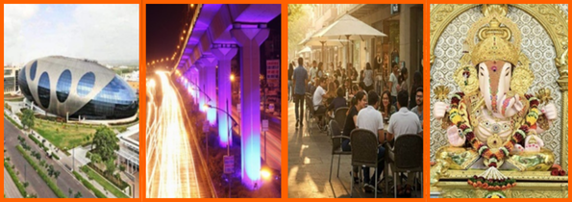
Expatriate Groups:
Pune has a vibrant and welcoming expatriate community, with several clubs and social organizations catering to foreigners and their families. One of the most well-known is the Pune Expat Club (PEC), which brings together expats from various countries through regular meetups, cultural experiences, and networking events. The group frequently organizes coffee mornings, themed dinners, city walks, and social mixers to help newcomers settle into the Pune lifestyle with ease. Another popular community is the InterNations Pune Chapter, where international professionals connect online and in person through curated events held at premium venues across the city. Whether you're looking to make friends, find local tips, or get involved in charity initiatives, Pune’s expat groups offer a supportive environment and a strong sense of community. Many gatherings are hosted at well-known venues such as the Conrad, Marriott, and local cafes, making it easy and enjoyable for expatriates to integrate into Pune’s dynamic urban life.
Entertainment and Leisure:
Pune, often called the cultural capital of Maharashtra, offers a perfect blend of tradition and modernity when it comes to entertainment and leisure. While it is a bustling hub of education, IT, and automotive industries, the city ensures its professionals and residents find ample ways to unwind. Whether you enjoy catching the latest blockbuster at a multiplex, exploring the local art and music scene, or relaxing with your family at a resort, Pune caters to every lifestyle.
The city boasts a vibrant nightlife with trendy pubs and rooftop lounges in areas like Koregaon Park, Viman Nagar, and Baner. For those who enjoy shopping and casual hangouts, places like Phoenix Marketcity, Seasons Mall, and Pavilion Mall offer a wide variety of retail and dining options. Pune is also home to several prestigious clubs like the Poona Club and Deccan Gymkhana, which offer sports, fitness, and social activities. Nature lovers and golf enthusiasts can head to the Oxford Golf Resort for a refreshing experience. With a mix of modern entertainment hubs and rich cultural spaces like art galleries, theatres, and music festivals, Pune offers a balanced and fulfilling leisure lifestyle for locals and expatriates alike.
Cinema Halls:
Cinema is a major form of entertainment in Pune, and the city is dotted with numerous movie theatres and multiplexes that cater to diverse audiences. Pune was quick to embrace the multiplex culture, and today it boasts a wide range of modern cinema halls offering the latest Bollywood, Hollywood, regional, and international films. Many of these theatres are conveniently located near popular restaurants and cafes, making it easy to plan a complete outing with family or friends. Prominent multiplex chains like PVR Cinemas, INOX, Cinepolis, and City Pride have multiple locations across the city, including prime areas like Kalyani Nagar, Viman Nagar, Baner, and Hadapsar. These theatres not only offer state-of-the-art sound and visual experiences but also provide a comfortable and enjoyable environment for all movie lovers in Pune.
Shopping Malls:
Pune is a shopper’s delight, offering everything from budget street shopping to luxury brand outlets. The city is home to numerous shopping malls that bring together retail stores, entertainment zones, restaurants, and kids’ play areas—all under one roof. Some of the most popular malls in Pune include Phoenix Marketcity, Amanora Mall, Seasons Mall, Pavilion Mall, Westend Mall, and SGS Mall. Whether you’re shopping for fashion, electronics, groceries, or enjoying a movie and dining out, Pune’s malls offer a complete urban experience for families and individuals alike.
Auditoriums:
Pune’s cultural richness is well represented by its many auditoriums spread across the city. These venues host a wide range of events, from classical dance and music performances to modern theatre, literary events, and workshops. Well-known auditoriums like Bal Gandharva Rang Mandir, Yashwantrao Chavan Natyagruha, and Tilak Smarak Mandir serve as platforms for creative expression and artistic appreciation, attracting performers and audiences from across Maharashtra and beyond.
Art Galleries:
Art enthusiasts visiting Pune will not be disappointed. The city boasts several art galleries that highlight the works of local, national, and international artists. Jehangir Art Gallery Extension, Darpan Art Gallery, and Bliss Art Gallery are among the popular spots where you can view stunning paintings, sculptures, and mixed media exhibitions. These galleries regularly host curated shows, making them a vibrant part of Pune’s growing art scene.
Amusement Parks:
Families looking for weekend fun can enjoy Pune’s amusement parks, which offer a mix of thrilling rides, water slides, and arcade games. Places like Appu Ghar, Sentosa Water Park, Diamond Water Park, and Wet N Joy provide entertainment for all age groups, with special play zones and water rides for children. These parks make for a perfect getaway to relax and spend quality time with loved ones.
Outside the City:
Pune’s location at the edge of the Western Ghats makes it an excellent base for exploring nearby hill stations, forts, and nature retreats. Popular weekend getaways include Lonavala, Khandala, Lavasa, Mahabaleshwar, and Panchgani. The scenic landscapes around Pune also offer trekking, camping, and other adventure activities for nature lovers. Whether it’s a peaceful hill retreat or an adrenaline-filled trip, Pune’s surroundings offer something for everyone.
Shopping Overview

Shopping in Pune City is an unforgettable experience every shopaholic dream of.
Pune, a dynamic metropolis blending tradition with modern flair, is a paradise for both bargain hunters and fans of luxury brands. As a thriving educational and IT hub, the city boasts a young, cosmopolitan population that keeps the shopping scene vibrant. Pune is dotted with everything from buzzing street markets to chic boutiques and sprawling malls. You can find everything—fashionable apparel, footwear, elegant jewelry, artisanal handicrafts like Paithani sarees and sandalwood items, antiques, electronics, and even automobiles—making it a true shopper’s delight.
The city features traditional markets lined along specific thoroughfares and modern malls housing dozens of shops under one roof.
Laxmi Road
This bustling thoroughfare is Pune’s premier shopping district, stretching nearly 4 km through the old city. It’s lined with shops selling garments, ethnic wear (especially Paithani sarees), jewelry, household goods, accessories, and textiles. Expect lively crowds, vibrant storefronts, and excellent bargains—especially around festival times.
Fergusson College Road
Known affectionately as FC Road, this street is packed with trendy fashion stalls, affordable accessories, and casual eateries. A popular hangout for college students and young professionals, it features nearly 450 shops offering everything from T‑shirts and shoes to quirky mobile accessories—all at wallet‑friendly prices
Tulshibaug (Pune’s Traditional Bazaar)
Situated in the heart of the old city below the Ram Temple precinct, Tulshibaug is famed for its wide selection of jewelry, household wares, religious items, cosmetics, and ethnic clothing. It’s ideal for one-stop shopping across a range of daily essentials and traditional goods
Hong Kong Lane (Fashion Accessories & Street‑Ready Style)
Located in the Camp/MG Road area, Hong Kong Lane is a narrow yet vibrant street lined with stalls offering ultra-affordable fashion accessories, sunglasses, belts, footwear, and chic clothing. It’s a budget fashion hotspot frequently frequented by students and younger crowds
Juna Bazaar (Vintage & Antique Finds)
Open only on Wednesdays and Sundays, Juna Bazaar is Pune’s iconic flea market. Chop through stalls to uncover vintage items—old coins, retro collectibles, vinyl records, antique furniture, and quirky memorabilia. It’s a treasure trove for secondhand and nostalgic shoppers
These streets provide a mix of traditional markets and trendy urban shopping—offering everything from ethnic sarees and antiques to youth fashion and accessories.
Each area of the city also boasts its own marketplace, offering everything from daily essentials to specialty items. Like,
Phoenix Market City (Viman Nagar, East Pune)
Amanora Mall (Hadapsar)
Pavilion Mall (Senapati Bapat Road)
Seasons Mall (Magarpatta City)
Westend Mall (Aundh)
Phoenix Mall of the Millennium (Wakad, Pimpri-Chinchwad)

Domestic Help Overview
Household Assistance – Maid Services
Like many other Indian cities, the household help sector in Pune is largely unorganized. The most reliable way to find a maid, cook, nanny, or other domestic help is through personal references, neighbors, or expat communities. Often, security guards, building staff, or other residents in your society can help connect you with someone trusted. While there are some agencies in Pune that offer domestic help services, they may not always follow through with proper background checks or police verification, despite claiming to do so.
The idea of hiring a full-time nanny is still not widely popular in Pune. Many families prefer training their existing maid to assist with childcare for a few hours a day. Expats may find that domestic helpers expect higher salaries from foreign families and might ask for additional money for travel, meals, or loans. It’s advisable to maintain clear boundaries—limit payments to agreed salaries and customary festival bonuses. Always lock away valuables and supervise help, especially during the initial period of employment.

